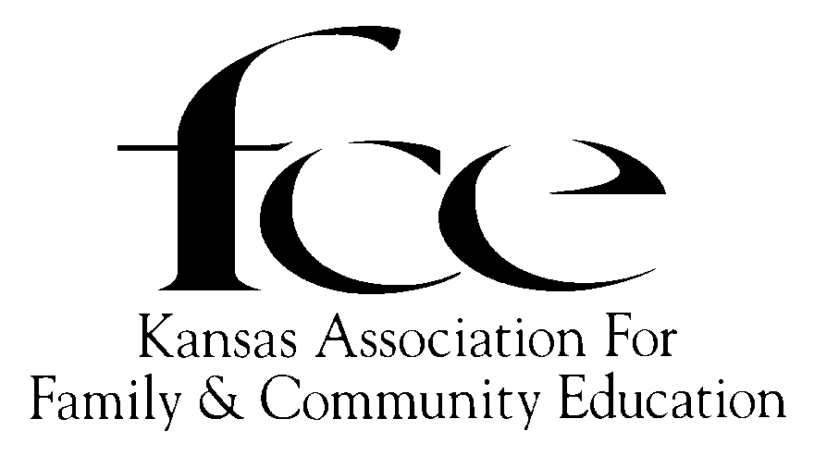
2024 ROSTER (Updated February 27, 2024)
BOARD OF DIRECTORS
Executive Committee

PRESIDENT
(24) Nancy Kernick – SE Neosho
628 South Santa Fe Ave, Chanute 66720-2449
H: 620-431-1353; C: 620-433-1405
nancyavon78@gmail.com

SECRETARY
(23-25) Tina Bailey – NE – Jackson,
15112 142nd Rd, Mayetta 66509-8795,
H: 785-966-2457; C: 785-633-5606; tina_fce@yahoo.com

PRESIDENT ELECT/VICE-PRESIDENT
(24) Faye Spencer – SC Saline
520 Gail Dr Salina 67401-7827
C-785-201-2143; spencerf.kafce@gmail.com

TREASURER
(24) DeLores Walden – NE Shawnee
5720 SE Paulen Road, Berryton 66409-9400
H: 785-379-0666 C: 785 215-4696;
wintersdj1@ cox.net

Area Directors

North East North West South East
(24-26) Diane Nielson- Atchison (23) Edith McClain - Smith (24) Cindy Kiser - Neosho
1511 Atchison 408 1st St 220 N Grant St.
Atchison, 66002-2245 Gaylord 67638-9748 Erie, 66733-1232
C- 913-488-5179 785- 697-2754 620-423-1766
diane.nielson@yahoo.com emcclain@ruraltel.net tkiser2@cox.net

South Central South West
(24) Linda Hess – Marion (24-26) Connie Chavez - Hodgeman
1222 Nickerson St 725 Atkin St
Marion 66861-1200 Jetmore, 67854-9305
620-947-1627 303-718-3349
lindalhess@hotmail.com chavez_17@msn.com

State Educational Program Committee
STATE EPC MEMBER’S term ends December 31 the year listed before their name. The member serves as State EPC Chair and listed on the Accomplishment Report the prior year listed before their name...
(24) Jennine Marrone-SE/Crawford (25) Ruth Shafer – SE/Montgomery (26) Susan Gartrell NW/Rooks
1105 Canterbury Rd 1252 CR 1700 415 6 Road, Stockton
Pittsburg, 66762 Caney, 67333 Stockton, 67669-8810
620-231-8942 C: 620-888-1101 785-689-4820
jmarrone50@yahoo.com C: 620-687-3582 gartrell@ruraltel.net
royshafer@gmail.com

Area Directors and Area EPC (updated 2/5/2024) Area EPC Chair serves the year prior to year listed before name. During year listed before name, term expires May 31 for Area EPC; Dec. 31 for Area Director.
VICE-PRESIDENT (24) Faye Spencer, 520 Gail Dr., Salina 67401-7827, 785-201-2143; spencerf.kafce@gmail.com
NORTHEAST
(26) AD: Diane Nielson, 1511 Atchison, Atchison, 66002; Atchison Co; C: 913-488-5179; Diane.nielson@yahoo.com
(24) Cheryl Anne Reves, 22300 Spring Creek Rd, Frankfort, 66427; Pottawatomie Co; C: 785-562-7524
careves@ksu.edu
(25) Tina Bailey, 15112 142nd Rd, Mayetta, 66509; Jackson Co; 785-966-2457, tina_fce@yahoo.com
(26) Margaret Barnes, 727 E 1650 Rd, Baldwin City, 66006; Douglas Co; H: 785-594-6408;
mbarnes1830@gmail.com
(27) To Be Announced after Area’s Spring Council Meeting.
NORTHWEST
(24) AD: Edith McClain, 408 1st St, Gaylord 67638; Smith Co; H: 785-697-2754; emcclain@ruraltel.net
(25) Eleanor Wherry, 2365 21 Rd, Plainville 67663; Rooks Co; 620-232-4202; eewherry@gmail.com
(26) Susan Gartrell, 415 6 Road, Stockton 67669; Rooks Co; 785-689-4820; gartrell@ruraltel.net
(27) Janie Lowry
SOUTH CENTRAL
(24) AD Linda Hess, 1222 Nickerson St, Marion, 66861; Marion Co; 620-947-1627; lindalhess@hotmail.com
(24) Lory Fisher, PO Box 884, Moundridge, 67107; McPherson Co; 620-794-6125; fisherlory@gmail.com
(25) Beverly Nickel, 8710 SE 24th St, Newton 67114; Harvey Co; H: 316-283-1113; dbnickel49@gmail.com C: 316-243-8777
(26) Mary Hammond,815 Pentwood Dr, Salina 67401; Saline Co; 785-404-8737; mcawichita@yahoo.com
(27) Kathy Preheim, 2008 58th, Peabody, 66866, 620-386-0778, kathypreheim@gmail.com
SOUTHEAST
(24) AD Cindy Kiser, 220 N Grant St, Erie 66733; Neosho Co; 620-423-1766; tkiser2@cox.net
(23) Carol Stephens, 217 W 2nd St, Erie 66733; Neosho Co; 620-432-4028; tcms@cox.net
(24) Mary Dunn, 2320 Florida Rd, Humboldt, 66748; Neosho Co; H 620-473-3521; maryfdunn@yahoo.com
C: 620-433-1316
(25) Donna Strickland, 11058 Wallace Rd, Oswego 67356; Labette Co; 620-795-4469; Dsfun345@hotmail.com
(26) Linda Dunekack, 1107 Twin Lakes Dr, Pittsburg, 66762; Crawford Co; 620-232-0543; lindadunekack@gmail.com
(27) To Be Announced after Area’s Spring Council Meeting.
SOUTHWEST
(26) AD Connie Chavez, 725 Atkin St, Jetmore, 67854; Hodgeman Co; 303-718-3349; chavez_17@msn.com
(24) Leanna Adams, 1135 Rolling Hills Rd, Garden City 67846; Finney Co; 785-443-0688; leanna54@gmail.com
(25) Connie Chavez, 725 Atkin St, Jetmore, 67854; Hodgeman Co; 303-718-3349; chavez_17@msn.com
(26) Ann Adams, 960 Ave. M, Bison, 67520; Rush Co; 785-650-3261; adamsann014@gmail.com
(27) Lisa Burdett, 9 43 N Rd, Larned 67550, Pawnee Co; 620-285-5830; mpb.dvm@sbcglobal.net.
2023 State Nominating Committee (Term June 1 prior year to May 31, year listed below.)
(23) CHAIR: SE – Sharon Giacometti, 221 E. 670th Ave- Farlington, 66734; sgiacometti@ckt.net (620)724-5303
(23) NE – DeLores Walden, 5720 SE Paulen Rd, Berryton 66409-9400, wintersdj1@ cox.net; 785-379-0666,
(23) NW Gertrude Deges, PO Box 25 Damar, Ks. 67632-0025
(24) SC Marlene Faul, 3000 Wildwood Way, North Newton 67117, marlene.violet@gmail.com; C 316-283-3342
(23) SE
(24) SW – Dorene Reimer, 1294 West County Rd P, Leoti 67861 620-874-5062 dreimer@wbsnet.org
ALTERNATES
(23) NE – Pat Weishaar -1108 Hwy 24, St. Mary’s, 66536-9780; pweishaar2016@outlook.com; 785-437-3160
(23) NW – Louise Greenberg, 218 E. Court, Smith Center, 66967
(24) SC –Bonnie Kaufman, 525 22nd Ave, Moundridge, 67107; msbeanie@mtelco.net; C 620-345-8962
(23) SE -
(24) SW – Karen Wiltse, 3526 Avenue V, Timken, 67575-7695, kkwiltse@gbta.net; 620-923-5026

Marketing Committee
Dorene Reimer, Chairman Geneva Wedel Jennine Marrone
1294 West County Road P 86 22nd Ave # 109 1105 Canterbury Rd
Leoti, 67861-6247 Moundridge, 67107-7003 Pittsburg 66762
620-874-5062 C: 620-245-5517 H: 620-231-8942; C: 620-687-3582
dreimer@wbsnet.org (no e-mail) jmarrone50@yahoo.com

KAFCE Conference Committee Coordinators
2023 – NW Edith McClain, 408 1st St, Gaylord 67638-9748, H: 785-697-2754, emcclain@ruraltel.net
2024 – SE Carol Stephens and Lois Carlson
2025 SW
(2026 NE; 2027 SC)

OTHER APPOINTED POSITIONS
PARLIAMENTARIAN WEBMASTER / EDITOR – KAFCE NEWS WILLIAM ALLEN WHITE
Judy Fullmer Marcy Price (26) Denise Marcum NW
4250 County Road C 11427 103 Rd 503 Walnut St
Dighton, 67839-8801 Ensign, 67841-9304 Lebanon, 66950
H: 620-295-1522 620-255-2001 C 785-282-4142
jfullmer@st-tel.net thesewinglady@yahoo.com deniseincenter48@yahoo.com

REGISTRAR/HISTORIAN/ MEMBERSHIP LIST/RECORDS
(24) DeLores Walden
5720 SE Paulen Rd
Berryton, 66409-9400
785 215-4696
wintersdj1@cox.net

American Income Life Insurance – (KAFCE insures each Board Member)
- Dee Hettinger – 316-516-1788 – dhettinger@ailife.com

NAFCE Headquarters
73 Cavalier Blvd. Suite 106, Florence, KY 41042-5178; Phone: 859-525-6401 Fax (859) 525-6496
Office Hours: 10:00 am to 5 pm (ET) - Tues, Wed, Thurs; nafcehq@fuse.net - www.nafce.org

NAFCE National Board Member from Kansas
President Judy Fullmer (24), 4250 County Rd C, Dighton 67839-8801, C-620-872-9990, jfullmer@st-tel.net
VP Programs: Peggy Martens (24) 812 Arrowhead Road, Inman 67546, (620)585-2302
Legacy Dorene Reimer -1294 West County Road P, Leoti 67861-6247, 620-874-5062 dreimer@wbsnet.org
Future of FCE Dorene Reimer -same as above
ASSOCIATED COUNTRY WOMEN of the WORLD (ACWW)
Bonnie Teeples, ACWW USA Area President, (Oregon), 541-891-2662; bdteeples@charter.net

K-State University Research & Extension Advisor- www.ksu.edu
Rick Peterson, PhD., Associate Director, Extension Programs, K-State Research & Extension,
340 Justin Hall, Manhattan, 66506, Office: (785) 532-1562, email: rlpeterson@k-state.edu
Kansas Extension Agents Family & Consumer Sciences Representative:
Liaison — Jessica Kootz, Midway District FCS Agent, 210 Kansas Ave, Suite 1, Ellsworth, 67439,
Office 785-472-4442; Cell 785-531-0069, jessicak@ksu.edu
K-State University Family and Consumer Science AREA Advisors
*NE Area Extension Specialist, Family & Consumer Sciences, Sharolyn Jackson, Area Office, 1007 Throckmorton Hall, 712 Claflin Road, Manhattan 66506; Phone: (785) 532-2273, sharolyn@ksu.edu
*NW Area Extension Specialist Family & Consumer Sciences, Jo Ellen Argabright, Rawlins County Extension, 406 State Street, Atwood 67730-1929; Phone: (785)626-3192; joargabright@ksu.edu
*SE Area Extension Specialist, Family & Consumer Sciences, Christina Holmes (cell 417-317-7257), PO Box 316, Parsons 67357-0316; Office: (620) 820-6123, christinaholmes@ksu.edu.
*SW Area Extension Specialist, Family & Consumer Sciences, Rachael Clews, MA, MS, CFLE, 4500 E. Mary St., Garden City 67846-9132; Phone: (620) 275-9164 x226, Cell: (469)233-1672; rclews@ksu.edu
*SC Area – Extension in Kansas does not have a SC Area/Regional Office

2024 National and Kansas FCE Dates to Remember
- February 14 Kansas FCE Executive Committee Meeting
- March 1 Kansas FCE Board of Directors’ Meeting
- April 15 Due date for National FCE forms, awards, honors and contest.
- April 29 Women Walk the World
- May 15 International Day of the Family
- June TBA Kansas FCE Board of Directors’ Meeting, State nominations forms due
- July 25-28 National FCE Annual Conference, Holiday Inn Cincinnati, Erlnger, KY
- August/September Kansas State EPC Leadership Training
- September TBA Kansas FCE Board of Directors’ Meeting
- October 7, 8, & 9 Kansas FCE State Conference, Holiday Inn Express, Chanute, KS
- October 13-19 National FCE Week & National Character Counts! Week
- November 24-30 National Family Week
2024 Spring Area Council Meetings dates:
NE – TBA per incoming Area Director Diane Nielson.
NW – April, Smith County
SC – April 15, West Zion Church, Moundridge, McPherson County
SE – May 2, Neosho Valley Event Center, Erie, KS
SW – TBA, per incoming Area Director Connie Chavez, Jetmore, KS

