2023 Accomplishment Report
(circle one) FCE Unit / County Council / Independent Member
"Support the Future with FCE”
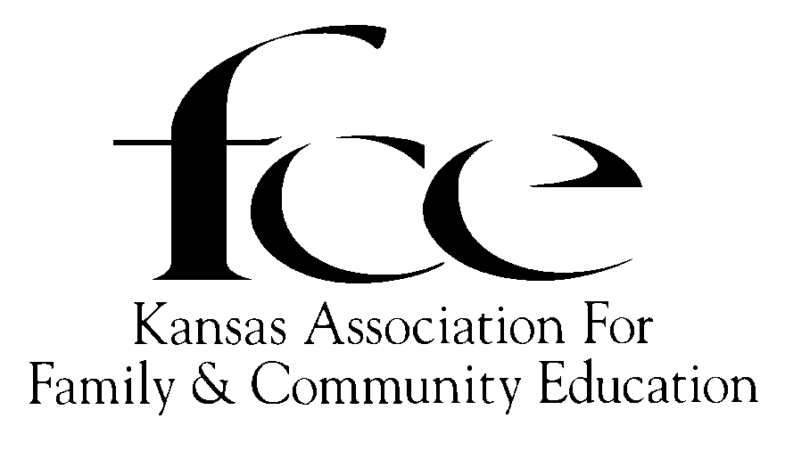

(Please complete using black or red ink.)
County: ________________________________ AREA (circle) NE NW SC SE SW
Name Independent Member or FCE Unit: ____________________________________________
Number members: In FCE unit ______ In County: _______; Number of Units in County _______
Report submitted by: ___________________________________________________________
Complete Mailing Address: _______________________________________________________
Phone (____) _______-_________E-mail: ____________________________________________
Tabulated Data has been collected by (circle one): FCE Unit / County Council / Independent Member
KAFCE Educational Program  Lessons | # of FCE Presenters | Lesson Given as E, L or A | FCE Volunteer Hours | # of FCE Members Reached | FCE Spent / Donated | # of Non-members Reached | Media/  Booth/  Display
Blueberry
CHARACTER COUNTS! –Caring
Essay & Artwork Contest.
CHARACTER COUNTS! –Caring
Lesson only
Container Gardening
Grandparents Raising Grandchildren
What is on your Device?
Other NAFCE written lessons: Title
_______________________
Healthy Body, Healthy Brain
Men’s Health, Arthritis
Men’s Health, Cancer
Totals All Above Columns

CRITERIA FOR ACCOMPLISHMENT EDUCATIONAL AWARDS
Check Mark either A or B
- ____ DO Judge on the 2023 program lesson: _________________________________.
To be judged as (circle one): [ FCE Unit / County Council / Independent Member ].
To be judged as the Category of (circle one): Education Leadership Action
- ______ DO NOT Judge. May summarize the year, if desire.

Due By December 1: FCE unit sends to CO. EPC. Independent member sends to State EPC.
Due By January 1: County EPC: Forwards ALL forms to AREA EPC
Due By February 1: Area EPC: Forwards ALL forms to: State EPC Chair.
Due By March 1: State EPC chooses FCE, Independent, & County Council winners in each category, reports winners to appropriate officers and submit reports to NAFCE.

100% Reporting AND Accomplishment Award: Please complete both pages following given outline about one lesson. One additional page, labeled (Name/FCE/County/Area) may be submitted to support your report. It may be a short informational summary, newspaper clippings, and/or photos.

100% Reporting and NO Accomplishment Award Please complete page 1. Indicate not to be judged.

_____ DO Judge on the 2023 listed program lesson: ___________________________________.

Number members: In FCE unit ______ In County: _______; Number of Units in County _______
To be judged as (circle one) [ FCE Unit / County Council / Independent Member ].
To be judged as the Category of (circle one): [Education / Leadership / Action ]
APPEARANCE OF REPORT (5 pts) [Overall neatness (2pts)]; [Followed outline provided. (3pts)]
OBJECTIVES/GOALS (15 pts) (Please complete using black or red ink.)
  - What impact would this educational program hope to make in the community? (3 pts)

  - How many non-members would you hope to reach? (2 pts) _________
  - Summarize plans, (include numbers), to describe the objective/goal(s). (10 pts)

ACTION (35 pts)
- What actions did members do to execute the goals for this program? (25 pts)

- Name other organizations group, agencies, etc. that were involved and describe how. (10 pts)

RESULTS (30 pts)
- Describe (include numbers) how well the program succeeded? (12 pts)

- Number FCE who participated. (6 pts) ______
- What impact/improvement did this program have on your community? (12 pts)

EVALUTAION (15 pts)
- Describe reaching goal. (Explain, using numbers, compare goals to results.) (10 pts)

- Describe how to improve the goals, plans and/or actions? (5pts)

