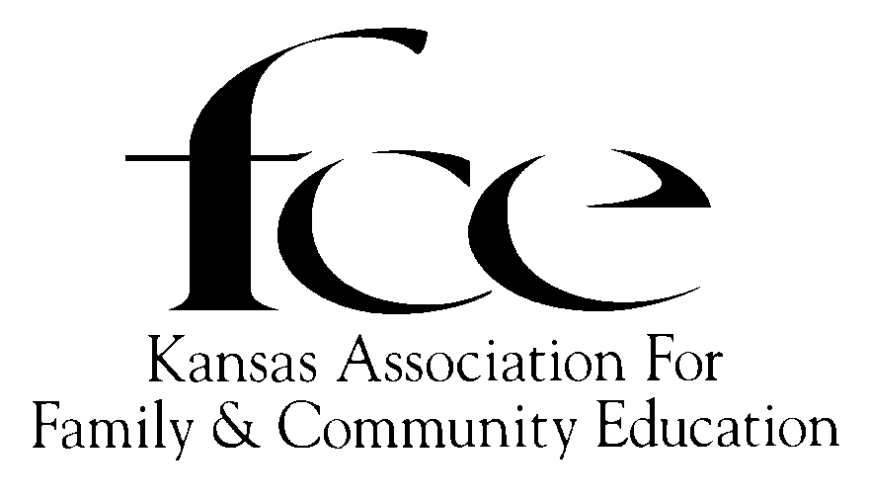**72nd Annual Kansas FCE Conference**

October 7-9, 2024 in Chanute, Kansas

**“Incredible Journey of FCE, Celebrating 110 Years”**

Conference Locations:

**Holiday Inn Express (HIE) Central Park Pavilion (CPP)**

3401 Blue Comet Drive 101 South Forest Avenue

Chanute, Kansas 66720 Chanute, Kansas 66720

Holiday Inn Express Location: off Hwy. 169 at Exit 35th Street/190th Road, go east on 35th St. to Blue Comet Drive, turn north and then back to the west on service road to Holiday Inn Express, just west of Love’s Station.

*For Reservations,* call directly to Chanute’s Holiday Inn Express at **620-431-0817,** use the **reservation booking code: FCE.** If reserved by **September 16, 2024,** there is a special conference rate of $129.00 plus applicable tax.

Conference rooms hold 1-4 people, all rooms are smoke free and equipped with a refrigerator, microwave, coffee maker, and hair dryer. There is also an indoor heated swimming pool and a fitness center. Also includes a **FREE Full Breakfast,** including items like eggs, bacon, sausage, cereals, juice, pancakes, and their famous cinnamon rolls.

**Conference Purpose:** To promote Kansas Association for Family and Community Education (Kansas FCE) programs, broaden Kansan’s perspectives, celebrate awards and achievements, receive leadership directions, and much more. To conduct the Annual Kansas FCE Business Meeting, including elections. To enjoy meeting other members from across the State of Kansas.

**Conference Registration and Confirmation:** Registration must be postmarked by September 1, 2024 to receive Early Bird conference rate. Confirmation will be sent via email. Please write your email address legibly on the registration form.

Make CHECK or MONEY ORDER payable to: **KAFCE Conference.**

**Mail to: Cindy Kiser, 220 N. Grant, Erie, KS 66733;** (Ph. 620-432-1766).

**Late Registration/Cancellation Refunds:** Registrations postmarked after September 1, 2024 will pay the regular rate. No refund after September 11th except for major medical emergency or immediate family member death. However, after September 11th registration can be transferred to another attendee.

**Meals** will include Monday evening, Tuesday lunch and evening banquet, and Wednesday luncheon. These will all be served at the Central Park Pavilion. **Please specify any special dietary needs on registration form.**

**Displays:** FCE Units or individuals must reserve space by September 15th to set up an informational display, special projects, or educational lessons. Reserve space by contacting: Cindy Kiser.

**Conference Questions and to reserve display space, contact:** Cindy Kiser, (620-432-1766), email: [Tkiser2@cox.net](mailto:Tkiser2@cox.net)

**2024 KANSAS FCE STATE CONFERENCE ACTIVITIES**

Conference Schedule in a Nutshell

**Monday, October 7, 2024**

1:00 - 4:00 Registration at HIE

2:00 - 3:30 Board Games at HIE

2:00 - 3:30 Humboldt Tour (Boarding at HIE, $5.00)

6:00 Dinner in Central Park Pavilion

Speaker: Safari Museum Representative

**Tuesday, October 8**

9:00 – 1:00 Registration, Prizes by the Yard,

& Marketing at CPP

9:00 - 11:30 Chanute Tour (Boarding at HIE)

9:30 - 11:30 Make and Take at HIE (limit 12 each)

9:30 - 10:30 Raffia Pumpkins ($5.00)

10:30 - 11:30 Wooden Socking ($5.00)

12:00 – 1:00 Lunch at Central Park Pavilion

1:00 – 4:00 Annual Business Meeting

Post Meeting Sharing Time Activity

6:00 Kansas FCE Banquet & Awards at CPP Speaker: Marla Day: “Dress for Success: Nelly Don and American Fashion”

**Wednesday, October 9**

9:00 - 11:00 Special Interest Sessions @ CPP

Tara Solomon-Smith, “Live Life to the

Fullest: Keys to Embracing Aging”

SE Kansas Mental Health Staff Member -

“Self-Care and Mental Health”

Julie Smith - “Don’t Get Scammed: Tips

and Tricks to Spot and Avoid Common

Fraud Schemes”

11:00 Lunch at the CPP

Speaker: Judy Fullmer, National FCE

President, “History of FCE”

**Conference Registration:**

Monday: 1:00 - 4:00 @ Holiday Inn Express

Tuesday: 9:00 -1:00 @ Central Park Pavilion

Conference attendees pick up name tags, event tickets and hostess bags at registration

**Prize by the Yard:**

Each FCE Unit or County Council may contribute at least one item or basket ($20.00 value) for the drawing, even Independent Members may donate. A ticket may be purchased Tuesday during the conference for $1.00 or $10.00 for a “yard” of tickets. Drawings for the items will take place Tuesday evening after the banquet. All proceeds go to the Kansas FCE Scholarship Fund.

**Board Games:** A variety of board games will be available on Monday from 2:00 - 3:30 at the HIE. Attendees may spend a relaxing afternoon meeting old and new friends, as they play various board games.

**Make and Take:** (limit 12 people per session). Tuesday sessions will take place at the Holiday Inn Express.

Raffia Pumpkins: 9:30 - 10:30. (Cost - $5.00)

Wooden Stockings: 10:30 – 11:30. (Cost - $5.00)

**Conference Tours:** The Neosho County Community College will provide bus transportation for the Monday and Tuesday tours. Attendees will be boarding at the Holiday Inn Express at the appointed times.

**Monday Tour:** Humboldt Tour: 2:00 – 3:30. (Cost- $5.00, Limit of 16). The revitalization of this southeast Kansas town has made headlines across the United States. Come see what they are talking about!!!

**Tuesday Tours:** Chanute Tour: 9:00 – 11:30. Chanute is home of the No. 1 ranked museum in Kansas, the **Martin and Osa Johnson Safari Museum**. It features exhibits on Martin and Osa Johnson, their lives and adventures as documentary filmmakers, photographers, explorers, authors, and naturalist during the years of 1917-1936, as they traveled to Africa and the South Seas. The museum is housed in the south part of the historic Santa Fe train station, while the **Chanute Public Library** is located on the north end of the train station; so, enjoy a quick visit to the library, too!

The **Chanute Historical Museum** is located within a block of the Safari Museum, features railroad items and oil and gas exploration, as well as, sports collections of baseball great Paul Lindblad, and basketball’s Ralph Miller. Around the corner is located the **Chanute Art Gallery**, home to a collection that includes Luigi Kasimer etchings, the Kansas Prairie Print Makers and local and area artist. During the month of October, the gallery hosts a quilt show of locally made quilts.

The **Cardinal Drug Store** is also the home of Chanute’s local soda fountain. Operating since 1979, it has a collection of Coca-Cola and pharmacy memorabilia. They also make homemade fudge to go with your soda-made the old fashioned way.

Just down the street is **Howard’s Toys for Boys** (Car Museum). Howard Alger has collected automobiles and automotive items for more than 50 years. When he retired, he opened his museum. It features a 1925 Cadillac, one of only three made that year.

**Keynote Speakers:**

**Monday Evening Meal**:

6:00: A representative of the Martin and Osa Johnson Safari Museum will share information about the Johnson’s adventures in Africa and the South Seas in the early 1900’s. After learning to fly airplanes in 1932, the couple used their planes to document their visits to Africa. Martin died in a commercial plane crash in 1937. Osa, a Chanute native, continued their legacy in her writings, public appearances, and television’s first wildlife series, *Osa Johnson’s The Big Game Hunt.”*

**Tuesday Evening Banquet**:

6:00: Marla Day, KSU, will present “Dress for Success: Nelly Don and American Fashion”. One can’t mention 20th Century women’s fashion without thinking of Nelly Don. The Parsons, Kansas, native built a fashion empire on the vision that women deserved affordable, stylish clothing regardless of status. Ellen “Nell” (Quinan) Donnelly’s story is one of innovation, triumph, and hard work.

**Wednesday Morning Special Sessions:**

9:00: Tara Solomon-Smith, an agent for K-State Research and Extension’s Southwind District, provides relevant, evidence-based information related to healthy, resilient people and communities. Originally from Southeast Kansas, Tara will share, “Live Life to the Fullest: Keys to Embracing Aging”. This session will explore ways to embrace each year with success as it comes. Topics addressed will be brain exercises, dealing with stress, and making time for yourself.

9:45: Chair Yoga: Do you have some aches and pains each day? Chair yoga is the answer. You will learn techniques to help get your muscles in shape to decrease aches and pains. A member of the Southeast Kansas Mental Health Staff will present: “Self-Care and Relaxation”. This session will provide an opportunity for participants to learn the importance of incorporating self-care and relaxation into their daily routines.

10:15: Julie Smith, a Family and Consumer Science Agent and Family Resource Management and Entrepreneurship Agent in the Wildcat Extension’s District, will present: “Don’t Get Scammed: Tips and Tricks to Spot and Avoid Common Fraud Schemes”.

**Wednesday Luncheon**:

11:00: Judy Fullmer, National FCE President, will present, “The History of FCE - Celebrating 110 years”. Since the humble beginning in 1914 to today has been an incredible journey.



**2024 Kansas FCE State Conference Registration Form**

**October 7-9, 2024 in Chanute, Kansas**

Conference Locations:

**Holiday Inn Express (HIE) Central Park Pavilion (CPP)**

Print NAME (for name tag)_________________________________________FCE ID#

Mailing Address:___________________________________City:_____________State:_____Zip

Email to receive confirmation ________________________________________ Phone #

Area (Mark One) _____ NE; _____ NW; _____ SC; _____ SE; _____ SW / County

FCE Unit Name:

Affiliation (Mark all that apply) FCE Member _____; Council President ______; FCS Advisor ;

State Board Member ______; Past State President ________; First Time at Conference ;

I will donate to Prizes by the Yard ______; I am willing to be a Hostess_____; Non-member ;

Special Dietary Needs:

Registration Fees: Early Bird Rate Regular Rate **Totals**:

Mailed Post marked: (By September 1) (After September 1)

**MEMBER**

Full Conference (includes all meals) $85.00 $100.00

Tuesday only (includes lunch & banquet) $50.00 $70.00

Wednesday only (includes luncheon) $50.00 $70.00

**NON-MEMBER**

Full Conference (includes all meals) $90.00 $110.00

Tuesday only (includes lunch & banquet) $65.00 $85.00

Wednesday only (includes luncheon) $65.00 $85.00

**Conference Fees for Tours/ Make and Take**

Humboldt Tour (limit 16) Monday Afternoon $5.00

Raffia Pumpkins (limit 12) Tuesday Morning $5.00

Wooden Stockings (limit 12) Tuesday Morning $5.00

**Total Amount Due:**

Please make check or money order payable to: **KAFCE Conference**

Mail payment and registration form to: **Cindy Kiser, 220 North Grant Street, Erie, KS 66733-1232**