_(year) Accomplishment Report:
Completed by (Check one) ____ FCE Unit; _____County Council; ____ Independent Member
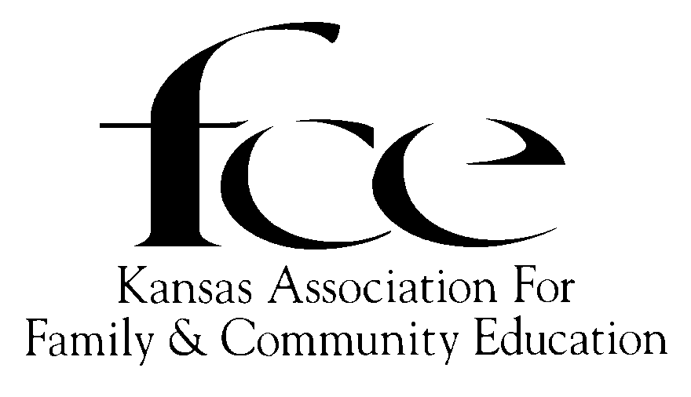

(Please complete using black or red ink.)
County: ________________________________ AREA (Check one): ___ NE; ___ NW; ___ SC; ___ SE; ___ SW
Name: Independent Member/FCE Unit/County Council:
Number members: In FCE Unit ________; In County: ___________; Number of Units in County
Report submitted by:
Complete Mailing Address:
Phone: _____________________ Email:
<<<<<<< Please, SAVE a copy of this report for your own records. >>>>>>

Kansas FCE Summary of Programs by Category of ALL LESSONS | Number of FCE Presenters | Number of FCE Hours Volunteered | Number of FCE Members Reached/Involved | Number of Other People Reached (lessons, media, booth, displays) | FCE $ Spent (include value if donated)
“E” Education
“L” Leadership
“A” Action
Totals
Check Mark either A or B A. ____ DO Judge; B. ______ DO NOT Judge.

Due By December 1: FCE Units send to County EPC. Independent Members send to State EPC Chair.
Due By January 1: County EPC: Forwards ALL forms (judged/not judged) to AREA Director
Due By February 1: Area EPC: Forwards ALL forms (judged/not judged) to State EPC Chair.
Due By March 1: State EPC chooses FCE Unit, Independent, & County Council state winners in each category. State EPC Chair: Mail all reports and summaries to the Kansas FCE Vice President.

The Area Directors, Area EPC Chair, and State EPC Chair names and address are listed on the sheet labeled: INSIDE FOLDER

100% Reporting AND Accomplishment Award: Please complete both pages following given outline about one lesson. (Current lessons are listed on the Inside Folders sheet.)

One additional page, labeled (Name/FCE/County/Area) may be submitted to support your report. It may be a short informational summary, 1 to 2 newspaper clippings, and/or 2 to 3 photos. Shingle pictures and newspaper clippers.

100% Reporting and NO Accomplishment Award Please complete page 1. Indicate Do Not Judge.
Education is presenting information on current lessons to members, families and the community.
Leadership is using training methods that empower learners to teach other groups using the current lesson.
Action is taking education into the next step of DOING work on a current lesson.

DO Judge on 2026 Education Program Guide lesson:

Number members: In FCE Unit ________; In County: __________; Number of Units in County
Submitted by (check one) [ ______ FCE Unit; ______ County Council; _____ Independent Member]
To be judged as the Category of (check one): [ _____ Education; _____ Leadership; _____ Action]
- APPEARANCE OF REPORT (5 pts) [Overall neatness (2pts)]; [Followed outline provided. (3pts)]
- MAIN FOCUS OF PROGRAM (15 pts) (Please complete by typing answers or use black or red ink.)
Why did you select this lesson? This lesson will be shared with whom, how shared, and how many: Or who, and how and how many do you intend to reach?

- ACTION (25 pts) What did members do in promoting the lesson?

- IMPACT AND SCOPE (35 PTS) How well did the lesson succeed, and what other organizations, groups, agencies, etc., were involved?

- EVALUATION AND SUMMARY (20 pts) Summarize work on the lesson in 200 words or fewer. Include how the plan worked and whether you would change any of the project. FCE members involved______
Non-members reached _____ FCE Spent $ or donated ______ Items number donated _______

FCE Education Program Activity Record Keeping

List Programs Presented | Indicate lesson Presented as "E" "L" "A" | Number of FCE Presenters | Number of FCE Volunteer Hours | Number of FCE Members Reached / Involved | Number of Others Reached (lessons, media, booth, display) | FCE $ Spent (Include value if donated)
January
What was the outcome of your program/lesson?
February
What was the outcome of your program/lesson?
March
What was the outcome of your program/lesson?
April
What was the outcome of your program/lesson?
May
What was the outcome of your program/lesson?
June
What was the outcome of your program/lesson?
July
What was the outcome of your program/lesson?
August
What was the outcome of your program/lesson?
September
What was the outcome of your program/lesson?
October
What was the outcome of your program/lesson?
November
What was the outcome of your program/lesson?
December
What was the outcome of your program/lesson?

The totals for all the lessons will be recorded on page one.

