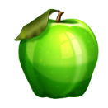 “A” is for Apple
2015 Lesson Compiled and written by Janie Williams, KAFCE State Education Program Committee

Leaders: This lesson is to be used with Hearth Fire Series # 27- “Someone’s in the USA saying: Show me the Power of Healing Foods”

INTRODUCTION
Apples have been around since the beginning of time. People all around the world enjoy eating fruit and apples are a favorite. Some individuals prefer eating them right from the orchard and others must wait and purchase them at the store. There are many popular apple recipes and pie is number one in America
EDUCATIONAL GOALS
Participants should learn the following:
*History of apples *Growing techniques and varieties
*Nutritional value * Popular uses *Apple Facts
An Apple for the Teacher
The apple is a symbol for teachers and teaching---students have given shiny fresh apples to teachers on the first day of school for over a century. The most common explanation for this custom is in the early years of education, poor farming families would pay their teachers with food and apples were a common produce.
It has been pointed out by some persons that, when young children learn the alphabet, each letter is associated with a word that they already know, “A” is for Apple, “B” is for Ball and so on. The apple is the symbol of an “A” and this is the grade most children desire, thus maybe the teacher will give them an “A” for their year’s work. It is said that if you are born in New England that apples are the “A” in your DNA, due to the abundance and variety of apples.
Apples come in all shades of red, green and yellow. Over 2500 varieties of apples are grown in the United States. Apple trees can be found in all 50 states, with 36 states growing them commercially. Top producing states include Washington, New York, Michigan, Pennsylvania, California and Virginia. American’s eat over 50 pounds of fresh apples and processed apple products each year.
History of Apples
It is believed that the apple arrived as a celebrated fruit at the beginning of the people of earth. Whether you start with Adam and Eve or the anthropological data on the Stone Age man in Europe, the apple was there. Roman and Greek mythology refer to apples as symbols of love and beauty.
The Romans brought apple cultivation to England after conquering them during the first century B. C.
It was in the fourteenth century that the story of William Tell shooting the apple of off his son’s head was established.
When the Pilgrims came to America they discovered crabapple trees, but the fruit was not very edible. The Massachusetts Bay Colony requested seeds and cutting from England for planting. American colonists called the apple “winter banana” or a “melt-in-your mouth”.
Newton Pippins were the first apples that were exported from America. In 1768 they were sent to Ben Franklin while he was visiting in London.
It was in the 1800’s when John Chapman, known to many as Johnny Appleseed, began his life’s journey. His dream was to produce so many apples that no would ever go hungry. He was portrayed as a dreamy wanderer but research revealed him to be a careful, organized businessman. He spent 50 years planting seeds and seedlings into nurseries and tracts of land from Massachusetts to Indiana.
Seeds from an apple given to a London sea captain in 1820 are sometimes said to be the origin of the State of Washington crop, now the largest producer in the U.S.
Our modern orchards combine the rich heritage of apple growing with research and field trials to grow an annual U.S. crop exceeding 220,000,000 bushels. New varieties are still being discovered. Some of these varieties are well known and others are new to the store: McIntosh, Red and Yellow Delicious, Empire, Rome, Spartan, Cortland, Granny Smith, Fuji, Braeburn, Pink Lady, Honey Crisp, Jazz and many more.
How to Grow Apples
Apple trees are grown from seed. It takes many years to go from a seedling stage to a producing tree. Most tree growers go to a nursery and purchase a seedling that has grown to a size that can be transplanted in your garden or yard. Others buy trees that are a couple of years old from a garden store. If you buy a small tree, it will take about three years to get your first fruit.
When planting a tree, select a location that receives full sunlight. It is very important to follow the directions given for planting the tree. Dig a deep hole, use mulch and plenty of water. It is recommended to stake the tree for the first year and fruit tree fertilizer spikes are a great way to boost the growth of your newly planted tree. The spike slowly releases a fertilizer specifically formulated for fruit trees.
In early May, apple trees are covered with blossoms. In order for the blossoms to bear fruit, they must be cross-pollinated. This means that the pollen must travel from one flower to another before fertilization can occur.

Bees are responsible for this task. If this doesn’t happen or the weather gets to cold there are less chances of have a good crop.
Apple trees can be vulnerable to a number of different diseases and pests. Chemical sprays are often used to limit the damage but organic methods are also popular.
Apple sizes depend on the weather and the apple variety and can range in size a little larger than a cherry to as large as a grapefruit.
The dwarf variety apple trees have become very popular because they take less space and generally grow only 10-15 feet. The science of growing apples is called pomology.
Varieties of Apples
There are over 7,000 varieties of apples grown around the world offering a wide selection of colors, qualities, variations of sweetness, firmness, size and appearance.
With so many varieties of apples, it can be over whelming to decide which variety to choose when, baking, cooking or just eating out of hand. This chart describes some of the best found in North America.

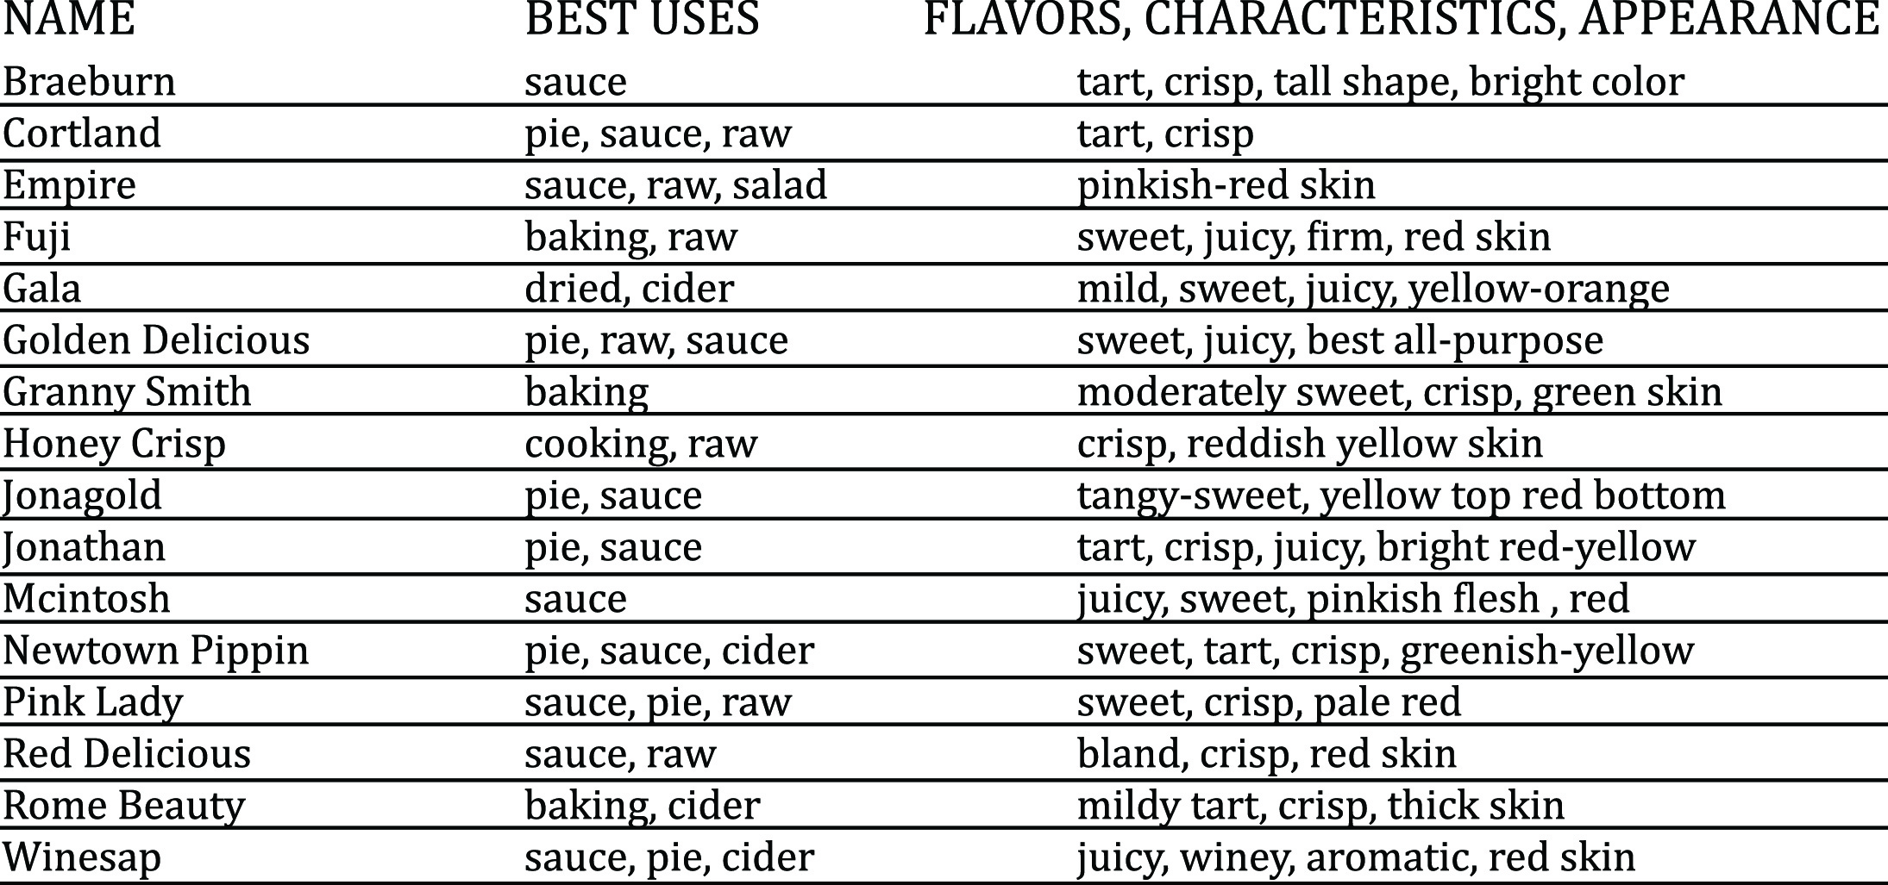

Not listed on this chart are the best for freezing—Golden Delicious, Rome Beauty, Stayman, Jonathan and Granny Smith. The K-State publication, “Preserving Apples”, offers additional freezing and canning information.
Apple Facts
The apple is a member of the rose family.
Apples have five seed pockets or carpels. Each pocket contains seeds.
A bushel of apples weighs approximately 45 pounds. Two pounds of apples make a one 9-inch pie.
Over sixty percent of apples are eaten fresh, and the rest are in processed apple products. Processed products can be juice and cider, dried or canned apples, baby food, jelly or apple butter, and vinegar. It takes about 36 apples to make a gallon of cider.
Apple Nutrition
There is an old saying “an apple a day, keeps the doctor away”. This saying comes from an old English adage, “To eat an apple before going to bed, will make the doctor beg his bread.” At first, people just enjoyed eating apples and feeling better for it. Over time, scientists and nutritionists studied the apple and learned the benefits of apples and other firm fruits. Sadly eating apples doesn’t guarantee good health, but they do have nutritional value and potential health benefits. So, munch, crunch, and enjoy!
A medium size apple:
- is sodium free and fat free
- contains natural sugars called fructose
- has only 80 calories
- is cholesterol-free
- contains no artificial colors or flavors
- is an excellent source of fiber
- is a convenient, satisfying snack
The Food Guide recommends two servings of fruit each day.
One serving is:
- one whole medium apple or one cup chopped apple
- ½ cup applesauce or ¼ cup dried apples
- 6 ounces 100% apple juice.
What kind of apple eater are you?
There are as many ways to eat an apple, as there are varieties.
- Compulsive Wedge: must have perfect, core- free wedges, arranged on a plate
- Splitter: cuts apple in half and removes the core and munches
- Top-to-Bottom: eats the whole apple from top to bottom in a straight line and then rotates and starts over until all finished
- Equator eater: the muncher takes bites from middle all the way around and then eats the top and then the bottom
- The Streak: this eater prefers to eat his apple in the nude. Peeling is removed often in one piece and eats either whole or in slices
- Core-Free Cruncher: they don’t care how the seeds come out, they must just be gone before eating the apple
- Stem Plucker: before taking a bite, the muncher grabs the apple‘s stem and twists, saying a letter of the alphabet with each turn. The letter will begin the name of your future spouse.

Peeling your Apple
The world’s largest apple peel of 172 feet and four inches long was recorded in 1976. Use a vegetable peeler to remove the apple skin, it will spare more flesh than a paring knife. Start at the top of the apple and circle down the circumference of the apple. When done correctly, the peel will come off in one piece. Some prefer quartering the apple before peeling.
The following offers five good uses for your apple peel.
- Make jelly- any apple peel will do, but red ones will add more color.
- Brew tea- add water to peeling and simmer, strain and then add, cinnamon, honey and lemon juice.
- Add to oatmeal- store peels in freezer and add them to simmering oatmeal along with raisins and cinnamon. Some prefer to process peels in a blender first.
- Add to smoothies- for extra fiber, throw in some frozen peels.
- Clean aluminum cookware-fill pan with water, add apple peels and simmer for about 30 minutes. The acid in the peel will remove stains and discoloration.
Core Values
There’s never only one “right” way to do anything and that includes coring an apple. The following are five ways so people swear by,
- Use an apple corer—sometimes the apple is too big and they don’t cut the core properly
- Half the apple vertically, and use a melon baller to scoop out the core.
- Cut the apple vertically into quarters and remove the core with swipe of the knife.
- Insert a long thin knife vertically, alongside of the core all the way down through the apple, cutting all the way to the bottom. Do this on all four sides of core then push out in one long skinny piece.
- Cut apple horizontally into ¾ thick rounds, then remove the core
from each slice.
Apples led the list of the Dirty Dozen fruits and vegetables, based on pesticides load. Before eating, wash your fruit like your hands, using soap or detergent and rinse before using.

Proverbs or Old Saying about Apples
We have all heard, and probably use, sayings that involve apples.
* comparing apple to apples *mom and apple pie
* one bad apple spoils the barrel * don’t upset the apple cart
* American as apple pie * rotten to the core
Fun Recipes for Kids of all Ages

Smiley Apple Sandwich
Core a Virginia apple all the way to the blossom end. Slice apple crosswise into ¼ inch rings. Spread apple ring with peanut butter and top with another ring. Cut apple sandwich into two smiley apple sandwiches.

Blushing Apple Milkshake
1 cup apple cider 1 heaping tablespoon cinnamon red hot candies
1 cup of milk 5-10 ice cubes
½ cup frozen yogurt- plain or vanilla
Combine juice, milk, yogurt, candies and about 5 ice cubes in blender. Blend on high, about 15 seconds. Stop blender and add more ice and continue blending on high until all candies and ice are combined. Pour into two tall milkshake glasses and garnish with a red apple slice.

Apple Giggles
1 package (3oz.) gelatin, any flavor 1 cup boiling water
½ cup water Virginia apples
Dissolve gelatin in boiling water; stir in cold water and set aside. Core apples, leaving the bottom in intact. Hollow out some of the apple flesh to make room for the gelatin. Pour gelatin in apple and place apples in individual bowls to keep them upright. Chill until gelatin is very firm. Cut into wedges to serve. Fun for kids, but also make an attractive garnish for a meat platter. Vary the flavors of gelatin and use both red and yellow apples to add a variety of color combinations.

Cidersicles- Cool Pops for Cool Kids
Fill small paper cups with apple cider and freeze partially. Insert a popsicle stick in each and freeze until firm. Peel away paper cup and enjoy a cool natural snack.

Carmel Apple Wrap
3 large tart Washington Granny Smith or Cripps Pink apples
10 wrapped caramels 5 flour tortillas (8inch), warmed
Peel, core and thinly slice apples. Place in saucepan; cover and cook over medium heat for 3-4 minutes. Reduce heat to low.
Unwrap the caramels and add to the apples. Cook and stir until the caramels are melted. Spoon mixture in the center of each warm tortilla; fold sides and ends over the filling and roll up. Serve immediately.

References and Resources: The Wichita Eagle Real Simple and allrecipes magazine “Apples” by Jacqueline Farmer, Washington Apple Commission and Virginia Apple Growers Association

