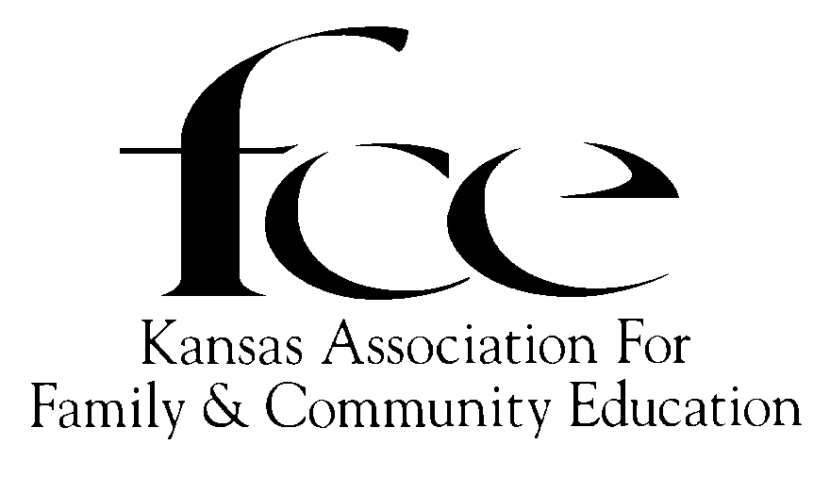

August, 2025

Dear Presidents of County FCE Council and/or FCE Unit Presidents,

The Kansas FCE Board of Directors and I are pleased to present the **2026 FCE Tool Kit** (aka “August Mailing”). It is our desire that this packet be a friendly, helpful companion as each FCE Unit, County FCE Council, and Area connect with one another to continue FCE’s impactful accomplishments into 2026.

Please take the time to read the forms and information provided. Some have been updated, others changed and new forms or information available. I appreciate the knowledge and guidance that you will share with the members. This being my first attempt to send out the “Tool Kit”, I hope that it will be complete, and will answer the questions that the members may have. If a member does not find the answers or solutions to a situation, they may contact me.

*The County FCE Council Presidents and the FCE Unit Presidents are the important key to being connected to the* *membership on the grass roots level.* Most of the pages in this “Tool Kit” packet are to be copied and distributed to the FCE Units (when more than one in the county) and Independent Members of that county. The pages may be sent by mail, email, or hand delivered.

If there are unforeseen difficulties to the distribution of the “2026 FCE Tool Kit” on any level, all members, and officers should know that alternative resources are available. The contents can be downloaded at [www.kafce.org](http://www.kafce.org/), in the August Mailing tab link, or contact Kansas FCE President Faye Spencer, Area Director, County FCE Council President, or K-State Extension Agent.

***The contents of this packet are divided into several categories:***

1. Information
   1. Kansas FCE Roster - Each FCE Unit and Independent Member needs a Roster to be able to reach anyone connected with any program that there are questions about.
   2. 2026 Education Program Guide – List of lessons provided by the Kansas State Education Program Committee (EPC) and K-State Extension Service.
   3. Kansas FCE Week Proclamation ~ This document may be used for publicity and honoring the members during the week October 12-18, of 2025 as the Kansas Family and Community Education Week.
   4. KSU – History of Research and Extension
2. Forms to be completed for Applications and/or Reporting
   1. Membership Form and the Membership Dues and Contribution Report Form
      1. One copy of the *Instructions* to FCE Unit Treasurer, County FCE Council Treasurer and Independent Member.
      2. One copy of the *Membership Dues and Contribution Report Form* to FCE Unit Treasurer, County FCE Council Treasurer and Independent Member.
      3. One copy of the *2026 Membership Form* to each FCE Unit member and Independent Member.
         1. Please, fill out completely, accurately, and legibly! Phone numbers and email addresses are necessary! Suggestion: if a member does not have email, maybe there is someone else who is willing to provide technical support or provide their email address.
         2. The bottom section under *“Please Indicate”* is important—check (√) all that apply. If you are County Council President, be sure to mark it and print your e-mail on the form.
         3. A current review of that information is very helpful for Marcy Price, Chairman of State Membership List/Records, to compile accurate membership lists and newsletter mailing labels.
      4. Due By:
         1. Oct. 1, 2025 – FCE Unit & Independent Members *with* County Council –Send to County Council Treasurer.
         2. Nov. 1, 2025 – County FCE Council Treasurer send to State Treasurer.
         3. Nov. 1, 2025 – Independent Members *without* County FCE Council; Send to State Treasurer.
         4. Forms may be hand delivered to the State Treasurer during the State Conference, October 9-11 in Dodge City
      5. Treasurer should retain one copy of each signed Membership Form and Dues and Contribution Report Form for own records.
   2. Heart of FCE Award Guidelines and Nomination Form
      1. The Kansas nomination essay is to one (1) page long. Must be current member of National FCE and Kansas FCE. Recent head photograph (2” x 2”)must accompany form.
      2. Each county may nominate one (1) Heart of FCE member.
      3. Submit to Area Director by October 1.
   3. Reporting the Death of FCE Member
      1. The FCE Unit President or Area Director should notify the State President and State Treasurer about the death of a member. A copy of the obituary should be included.
      2. The State President will notify the Membership List/Records Chairman, who informs the National Treasurer.
      3. The *KAFCE News* will publish a Memorial List in the March issue.
   4. Reporting the Dissolution of FCE Unit
      1. The FCE Unit members vote to dissolve by a two-thirds majority.
      2. All financial and other property shall be assigned to the Kansas FCE.
      3. Official notification should be sent to the State President, Area Director, Registrar and County FCE Council President.
   5. County FCE Council Officer Report
      1. Vital to promote communication between the grass roots membership and the Area Director and State President. List the officers, and the county’s K-State Extension representatives. Due by December 1, 2025.
      2. If there is only one FCE Unit in the county, then the FCE Unit becomes the County FCE Council, thus listing the unit’s officers.
   6. KlamathInsurance Center, Inc. ~ This is a liability insurance provided to Kansas FCE by National FCE. If any FCE Unit or Council is sponsoring an event or activity that involves non-FCE members, *including* your monthly local FCE Unit meetings, a request for Certificate of Insurance can be obtained by filling out this form. Tips for completing this form are included. If there still are questions, contact the Insurance Company (on the Roster),
   7. Scholarship and Grant Applications
      1. Kansas FCE Scholarship is provided to give financial assistance to students presently attending or planning to attend a 2 or 4-year **Kansas** college or university majoring in a field that promotes the physical, social, and emotional well-being of individuals, families, and communities. Application deadline to State President is March 1. Donations are accepted. Refer to the Membership Dues and Contribution Report Form. Also funded by “Save the Ink Cartridge” campaign.
      2. The Joann Newby Adult Education Grant is provided for financial assistance to a recipient wishing to “reenter” the labor force; enable the recipient to move to a higher level employment in present field or to an occupation in a more highly skilled field. Application deadline to State President by June 1. Donations are accepted. Refer to the Membership Dues and Contribution Report Form.
      3. Ruth B. Sayre Scholarship is available from Country Women’s Council USA memorial scholarship fund. The $500 is offered for the purpose of fostering educational development of women. Donations are accepted. Refer to the Membership Dues and Contribution Report Form.
   8. CHARACTER COUNTS!® - National FCE Essay and Artwork Contest, 2026 Character Value: ”Respect”; Contest for the 4th grade student, i. e. in public, private or home schools, 4-H, youth scouts, or church groups, etc. National FCE’s Essay and Artwork Contest promotes FCE’s literacy programs, “CHARACTER COUNTS!”, and community involvement. The purpose of the 2026 contest is to encourage students to understand and practice Respect, one of the Six Pillars of Character. The contest encourages students to strive for excellence and creativity in reading, writing and drawing skills.
   9. CHARACTER COUNTS!® - National FCE Essay Contest for High School Age students. 2026 Character value: Respect. This contest provides students the opportunity to write about the character theme of the current year while learning a little about the FCE organization. It also provides student with the opportunity to earn award funds by winning at the state and national level.
   10. National Community Service Project Report Form: This form’s deadline is April 15, 2026 to National FCE Headquarters. It would report the service project completed by FCE Unit, County FCE Council or Independent Member.

**County FCE Council Presidents’ Check List**

* **Copies to be made and distributed** ~ The entire August Mailing is to be sent to each FCE Unit President and Independent Member in your county.
  + Each unit is then responsible to print as many copies of any of the forms as they may need. Use e-mail preferably (it’s free), USPS, or hand deliver.
  + Independent Members, who have a County FCE Council, will need to be “taken care of” by their respective County FCE Councils. “Taken care of”means that the Independent Members will receive from the County FCE Council President, by mail, email, phone call or hand delivered, all FCE information, forms and newsletters, anything that they might need to know and to be connected to all levels of the FCE organization.
  + Independent Members, *who do not have* a County FCE Council, will be “taken care of” by their respective Area Director. *Connection is so vital!*
* **County FCE Council Officer’s Form** To be connected, the Area Director and State President *must* know who the County FCE Council officers are! *Send copies to Area Director and State President by December 1, 2025.* Maintain one copy for county council records. The August mailing is so difficult without this information especially phone numbers and email address! Suggestion: if a County FCE Council President does not have email, have another officer/member, friend or someone’s email (indicate who is that contact) who is willing to provide technical support. This will ensure that any and all information will be received by the county, FCE Units and members.
* **Keep Your Tool Kit** ~ Do not delete this 2026 Tool Kit. until you receive the 2027 Tool Kit. As an officer, you are a resource for these documents and forms! Maintain a hard copy as well as the digital copy. The 2026 Tool Kit is also being shared with your county’s K-State Extension Agents. They, also, can be resources for copies.

I know this is a lengthy and detailed letter, but if you have any questions, please contact me so situations or questions may be resolved in a timely manner.

Sincerely yours,

Faye Spencer

Kansas FCE State President

520 Gail Drive

Salina, KS 67401-7827

(785) 201-2143

spencerf.kafce@gmail.com