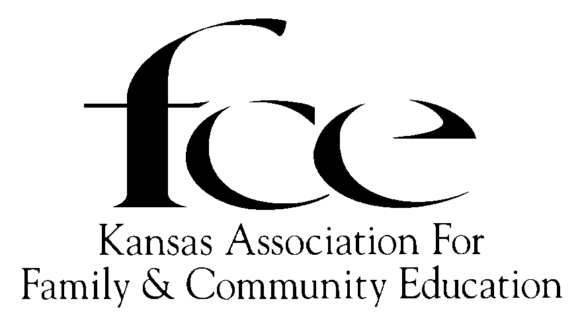

August, 2025

Dear K-State Extension Agent,

I am a newly elected Kansas FCE State President. This is the first year to be sending the out a mass email known as the “August Mailing”. It is the 2026 Tool Kit for FCE Units, County FCE Councils and Independent Members.

The K-State Extension Service is an important link to provide not only education program lessons but as a resource for our members to maintain the connection between the various levels of National and Kansas FCE. Some members do not have a computer, or lack the technical skills or knowledge to obtain National and/or Kansas FCE and/or K-State materials. It is our wish that County or District Extension Agents offer assistance in this need.

A digital copy of the 2026 FCE Tool Kit is being emailed to each K-State Extension Agent who has at least one FCE Unit and/or Independent Member in his/her respective counties or districts. This digital copy should be kept on hand so that if an FCE member has need of any of the Kansas FCE materials, he/she may ask you to print a copy and until the 2027 Tool Kit is sent,

Thank you in advance for helping Kansas FCE keep our members informed.

Sincerely,

Faye Spencer

Kansas FCE State President

520 Gail Drive

Salina, KS 67401-7827

785-201-2143

Spencerf.kafce@gmail.com