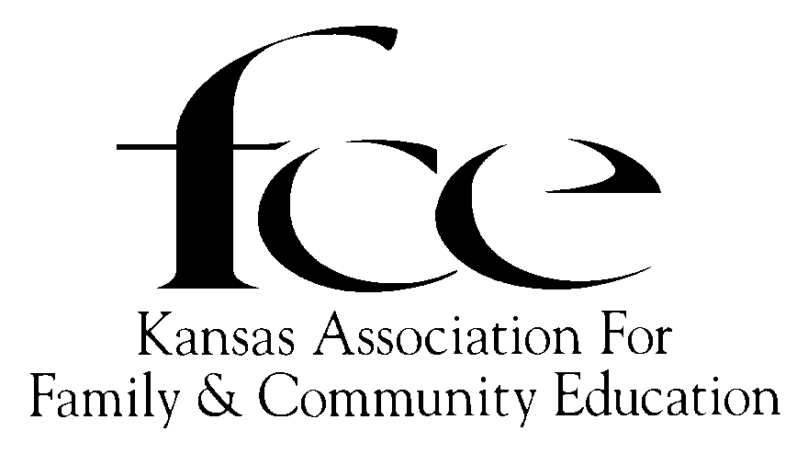

August, 2025

Dear Kansas FCE Independent Member,

Greetings from your State President and the Kansas FCE Board of Directors. We congratulate you on your accomplishments this past year and look forward to working with you again in 2026.

This is the 2026 Tool Kit (aka August Mailing). Included are the forms, instructions, and other vital information necessary for the upcoming year. Please check and note all **DUE DATES**.

**2026 FCE Membership Dues Form and Contribution Report** ~ Please, fill out completely, accurately, legibly and with a signature. Phone numbers and email addresses are necessary! Suggestion, if you do not have a telephone number or an email address, provide contact information of a friend or relative who may be willing to furnish technical support. Senior membership fee applies to anyone that will be eighty (80) or more years by December 31, 2025. **Birth date** must be on the membership form.

Information obtained about National FCE:

* The 2025 NAFCE Conference was held in Erlanger, Kentucky. Bonnie Teeples of Oregon, was elected National FCE President. DeLores Walden, Kansas, was elected as National FCE Secretary.
* The 2026 National FCE Conference will be held in Erlanger, Kentucky and celebrate 90 years of FCE.
* The FCE week is set for October 12-18, 2025. The FCE Week Proclamation is included if you chose to have a Proclamation signing in your city or county.
* National FCE Essay and Artwork Contest, 2026 Character Value: ”Respect”, one of the Six Pillars of Character. Contest for the 4th grade student, i. e. in public, private or home schools, 4-H, youth scouts, or church groups, etc. If you are interested in reaching out to any fourth graders, please let me know and I will send you a copy of the contest criteria. Or contact your local Extension Agent.
* National FCE Essay Contest for High School Age students. 2026 Character value: Respect. This contest provides students the opportunity to write about the character theme of the current year while learning a little about the FCE organization.

Will plan to see you in Dodge City October 9-11, 2025 for the State Conference. Everyone is really looking forward to spending time with members and renewing friendships.

Sincerely,

Faye Spencer, Kansas FCE State President

520 Gail Drive

Salina, KS 67401-7827

785-201-2143

Spencerf.kafce@gmail.com