WHERE IN THE WORLD IS TURKU?

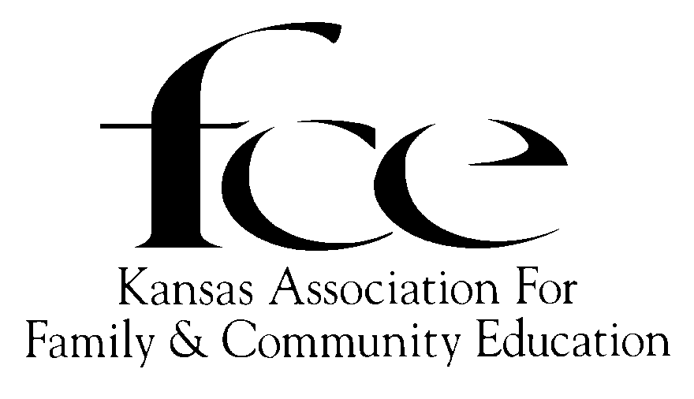
Turku, Finland is the home of the 25th Triennial for the Associated Country Women of the World in June of 2007.
This lesson was written by Marcy Price, KAFCE President - Elect.
Leaders Guide and Handout

Educational Goals:
- To learn about Finland and Turku.
- To keep updated with the happenings of ACWW and CWC.

Community Activities:
- Give this lesson to another group.
- Plan a celebration such as District Recognition Day using the Finland theme.

Introduction
The ACWW 25TH Triennial Conference will be held in Turku, Finland, 2-10 June 2007. Turku is the oldest city in Finland. The city has many hotels and fine restaurants as well as tourist attractions in close proximity, including Turku Castle and Turku Cathedral, both of which are over 700 years old. Turku celebrated its 775TH anniversary in 2004. Turku is also well known for its location in a beautiful archipelago with a number of outdoor activities. The time of the conference, early June, is a pleasant season in Southwest Finland with mostly sunny weather. The city has an international airport as well as frequent ferry service to Sweden and other destinations on the Baltic Sea. The attractions in Finland, in the Scandinavian countries and in St. Petersburg and Tallinn can be easily reached from Turku.

FINLAND
Finland is a republic which became a member of the European Union in 1995. Its population is 5.2 million. The capital Helsinki has a population of 560,000.
Finland is in northern Europe between the 60th and 70th parallels of latitude. A quarter of its total area lies north of the Arctic Circle. Finland’s neighboring countries are Sweden, Norway and Russia, which have land borders with Finland and

Estonia across the Gulf of Finland. Forest covers three quarters of the country’s surface area of 338,000 sq. km.
Finland is a country of some 190,000 lakes and about 180,000 islands. Europe’s largest archipelago, which includes the self-governing province of the Aland Islands, lies off the South-west coast.

History
Finland was a province and then a grand duchy under Sweden from the 12th to the 19th centuries and
an autonomous grand duchy of Russia after 1809. It finally won its complete independence in 1917. During World War II, Finland was able to successfully defend its freedom and resist invasions by the Soviet Union. In 1995 Finland became a member of the European Union and was the only Nordic state to join the euro system at its initiation in January 1999.

Government
Finland is a republic, with a democratic and parliamentary form of government. The country is governed under a constitution that was adopted on July 17, 1919.
The head of state is the President of the Republic who is elected for a period of six years and may serve a maximum of two consecutive terms. The President is chosen by direct popular vote, with a run-off between the two leading candidates if no candidate wins an overall majority in the first round of voting. In 2000, the Finns elected their first female president, Tarja Halonen.

Climate
The climate of Finland is marked by cold winters and fairly warm summers. Despite Finland’s northerly geographical position, the climate is not as freezing as one might think. Summer in Turku is usually warm and bright. The average July temperature is 70° and the weather is mostly sunny. However, some rain may occur, as well as chilly wind in the evening, so take warm clothing and an umbrella along with you. It is light for most of the night for several weeks during the summer time.
In February the average is about 16° F. Precipitation (including snow and rain) average about 18 in. in the north and 28 in. in the south. Light snow covers the ground for four or five months a year in the south and about seven moths in the north.

The People
Finland is the sixth largest country in Europe in area, with a low population density of 17 persons per km² . Nearly two-thirds of Finns live in urban environments: the population of Turku is 173,000. There are two official languages in Finland: Finnish and Swedish. Many Finns speak at least Basic English, especially the younger generation and people with higher education. Turku is one of the official bilingual towns.

Economy
Forests are still Finland’s most crucial raw material resource, although the engineering and high technology industries, spearheaded by the Nokia Corporation, have long been the leading branches of manufacturing. Electronics is the most spectacular success story in Finnish exports. Its remarkable growth in the 1990s was mainly based on mobile phones and other telecommunication equipment. The net wealth of Finnish households is at the average level for member states of the European Union.

Culture
Finland has an exceptionally high number of significant composers and conductors. World famous are also Finnish design and architecture.
Finland possesses a wealth of folk music and a large body of church music, the former amassed since ancient times and the latter developed since the acceptance of Christianity by the Finns in the 12th century.

Turku
Turku in the Southwest corner of Finland is the oldest city and the first capital of the whole country. Today it is the capital of its region, the Southwest Finland. Turku is a fascinating combination of both old and new. Turku is often said to be the only West European town in Finland as all medieval European towns have four things in common: a river for transport, a cathedral for religious power, a castle that represent the secular power and last but not least - a market place for acts of commerce. Turku has them all! Turku has a lively and versatile cultural life: several theatres, a city philharmonic orchestra, chamber music, jazz & rock etc. The art-exhibitions and permanent collections in the city museums and art galleries are highly recognized both in Finland and abroad.
Today people fly to Turku from Copenhagen, Stockholm and Helsinki, though this had not always been the case. The sea used to be the most important connecting route, and Turku was founded as a trading place. However, as its official year of establishment the town celebrated the time when it also became the spiritual center of the country, a time when the bishopric was established in Turku. In 2004, the oldest town in Finland (Turku) celebrated its 775 year old history. Turku has been the center of Finnish spiritual culture for centuries. The first Finnish University was established in 1640. It was here that the greatest leaders in development of Finnish civilization used to study, from the creator of the Finnish literary language to their national poet. Today, Turku has three universities, catering for a total of 202,000 students. Visual art, music literature and theatre are strongly represented in the cultural offerings of the town.
Today’s Turku and the province of Southwest Finland that surrounds it constitute the second most important economic are in Finland. Turku has 173,000 inhabitants, and the whole are a total of nearly 300,000. Southwest Finland belongs to the oldest agricultural area in Finland, but nowadays its versatile trade’s structure covers, among others, the food and pharmaceutical industry, the metal industry and ship building. In recent years, Turku has become, above all, a growth center of biotechnology and the ICT field.
The picture of today’s Turku is a combination of old and new. The most significant monuments of Finnish history, Turku castle and the cathedral are located in Turku. They are both situated by the Aurajoki River, near the numerous other historical sights of the town. The banks of the river also provide a pleasant promenade with cafes and restaurant ships for both inhabitants of Turku as well as tourists.

Turku Castle and Historical Museum
The Turku Castle is a culturally historical tourism attraction that is over 700 years old. The Castle has a museum, which demonstrates the history of the Turku region from prehistory to present day with its frequent exhibitions, events and furnished style rooms.

The Martha Organization (Marttalitto)
There are three Finnish societies: The Martha Organization (Marttalitto), The Swedish Martha Association in Finland (Finland’s Svenska Marthaforbund r.f) and the Rural Women’s Advisory Organization (Maa- ja kotitalousnaiset.).
The Martha Organization (Marttalitto) is a Home Economics Extension Organization, which was founded in 1899 to promote the quality and standard of life in the home. It also carries out cultural and civic education. The Marthas enhance the use of nutritious food, take care of the near environment and kitchen gardens and help families to mange their economies. The Organization has 50,000 members.
The Martha Organization funds a development cooperation project in Burkina Faso where a bakery using solar energy is being founded. With the profits of the bakery a local women’s NGO, Pag-La-Yiri, will employ extension workers to teach nutrition and hygiene questions in 200 Burkina be' villages.

The Swedish Martha Association in Finland (Finland’s Svenska Marthaforbund r.f)
The Swedish Martha Association in Finland (Finland’s Svenska Marthaforbund r.f). ) is anon-political advice and civil organization in Finland with 10,500 members. The vision of the Martha Association is that all homes and families have the skills and resources to maintain a balance in everyday life and a sustainable development economically, as well as ecologically and socially. The activities of the Martha Association involve the Finnish society as a whole, in particular the Swedish-speaking areas and Aland, as well as international work.

The Rural Women’s Advisory Organization (Maa- ja kotitalousnaiset.).
The Rural Women’s Advisory Organization (Maa- ja kotitalousnaiset.) is a nationwide organization for advice directed at households and consumers, the promotion of landscape management and small enterprises in rural areas. With a membership of 75,000 it is one of the largest women’s organizations in Finland. On a municipal and village level the members establish their own associations, which currently number over 2,000. The actual advisory work occurs at the 16 national Regional Centers, which operate in connection with Rural Advisory Centers.

This lesson was reviewed by:
Cheri Kasper, KAFCE Vice President, Arlington
Amy Price, B.S. Education, Manhattan

This lesson was funded by the Kansas Association for Family and Community Education. Sept 2006
Acknowledgements
Country Women’s Council USA News Sheet
Volume, 18 Issue 2 Summer 2006
www.virtual.finland.com
www.martat.fi

All educational programs and materials are available without discrimination on the basis of race, color, religion, national origin, sec, age, or disability.

Recipes from Finland

Kaalikääryleet (Cabbage Rolls)
(For four or five)
Filling:
1 lb. of lean minced pork or beef
1 onion
½ cup cabbage cooking liquid
1 cup chopped cabbage
1 cup boiled rice
1 tsp salt
¼ tsp white pepper
1 tsp. marjoram

Topping:
1-2 tbsp syrup
Butter or margarine
Cabbage cooking water for basting

Gravy:
1 ½ cup pan juice
2 tbsp flour
A little cream

Cut the stalk off the cabbage and cook the cabbage in salted water until the leaves are soft. You can carefully loosen the outer leaves as they soften. Lift the cooked cabbage onto a large plate to drain. Loosen the leaves one by one and chop the small inner leaves for the filling.
Chop the onion and fry in a small amount of oil until translucent but not brown. Combine the meat, rice, chopped cabbage and seasonings into a smooth mixture. If the mixture is too thick, add some more of the cabbage cooking water.
Flatten the cabbage leaves. Lift a good tablespoonful of filling onto the leaf and roll it up tucking the edges round the mixture. Place the rolls side by side in a baking dish, pour syrup and a little fat over them. Bake the rolls for 1 hour at
400°

Köyhät ritarit (Poor knights)

a slice of French bread or coffee bread per person
1 egg
1 ½ cups milk
pinch of salt

For frying:
butter or margarine

On top:
lingonberry jam (and whipped cream)

1. Cut a thick slice of bread for each person
2. Whip the egg and mix in milk and a pinch of salt
3. Dip the slices in the milk and egg mixture
4. Fry until golden brown on both sides
5. Serve hot topped with a bit of lingonberry jam. If you top it all off with whipped cream, your "poor knights" become "rich knights".

Tippaleivät (May Day Cookies)

Tippaleipä
2 eggs
2 tsp sugar
1 tsp salt
1 cup milk
2 cups flour
½ tsp vanillin

To fry:
Vegetable or coconut oil

Mix the eggs and sugar, but don't beat! Add the other ingredients and stir into a smooth batter.
Put the batter into a paper cone or a pastry bag fitted with a small-holed nozzle.
Squeeze the batter in a thin band into the hot oil. Use a spiral motion to form nest-like cookies. If possible, use a metal ring in the pot to keep the cookies in shape. When the cookies have turned golden brown, remove and drain them on paper towels. Dust the cold cookies with powdered sugar.

